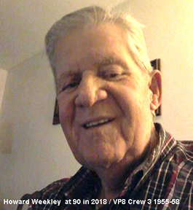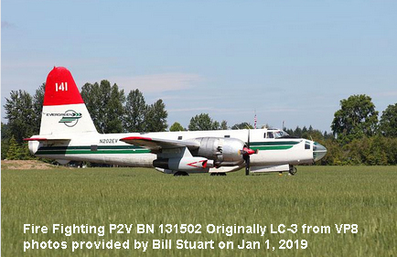

Bill Stewart <oldgoat1822@aol.com>

To:papa3878@bellsouth.net

Jan 2 at 2:42 PM

Ralph,  
  
Howard Weekley was in the squadron when I was assigned to VP8 out of A school in May of 1955 and he was still the Plane captain on LC3 when I was separated from the Navy in June of 1958. He was my Plane Captain on HD3 Buno 124902 when I was first assigned to crew 3 as a second radio operator in 1955. The crew picture that I gave to you was taken in 1957 right after they changed the tail letters to LC on our new plane LC3 Buno 131502. Not long after the crew picture I was assigned to crew 4 and we deployed to Scotland and my last deployment was to the Azores. I was then sent to Chincoteague for separation. I lost contact with Howard and everyone else except Frank Magee until Sheila and I found our first reunion in Virginia Beach in the early to mid 90's and the grouchiest woman in the world (Beth Perry, Love Her) signed me up and sent me the newsletter and roster of the Alumni Association. That's where I found Howards address, phone, and e-mail. He was a member until his Navy son was killed in a motor cycle accident in the 90's. I tried my best to try and get him and his wife Justine to come to some of the reunions to no avail. Don't know when he retired but do know that he made CPO. He passed away on May 16, 2018 at the age of 90. If you type in Howard Weekley Kingston RI you should be able to get his obituary. He was involved with getting a P2V to Quonset Point to start a museum but things fell apart and they just scrapped the plane a couple months ago. The last plane we flew in together Buno 131502 was refurbished by the Evergreen Corp. as a fire fighter and was sold in the past year or so for $100,000.00 in flying condition. Will try to attach a photo of Howard and also one of LC3 Buno131502 as a fire fighter. By the way Ralph, I still have every Newsletter from the first one I got in the 90's. To the last one I just got from Carol.  
  
May you and you family have a Happy Healthy New Year.  
  
Bill